Task 001:

Create a code to display

“Hello guys!!!! “

“We are learning Java”

Using a single output statement…

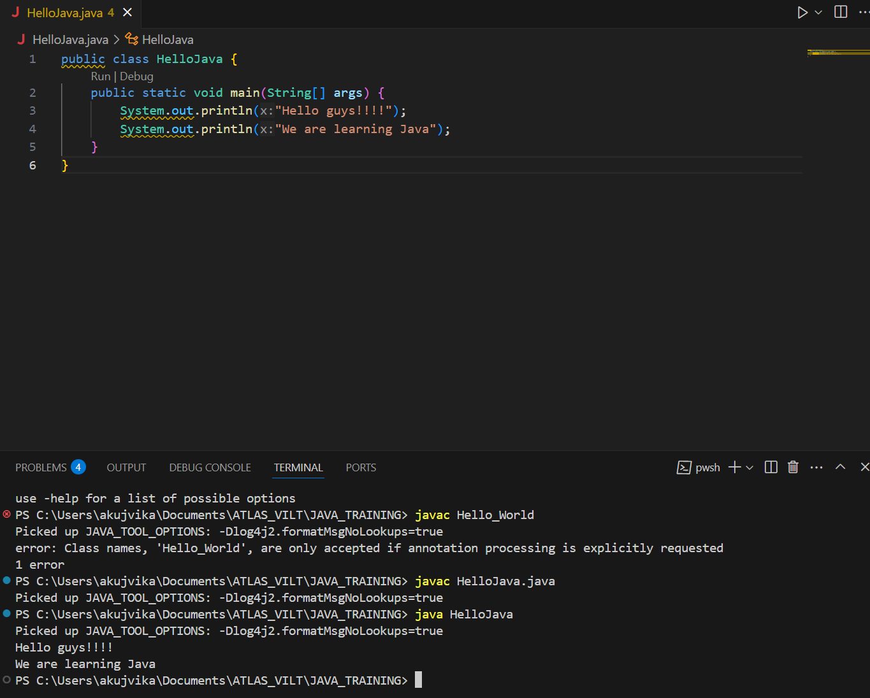

Task 002:

 Write a Program in Java to Add two Numbers.

Input: 2 3

Output: 5

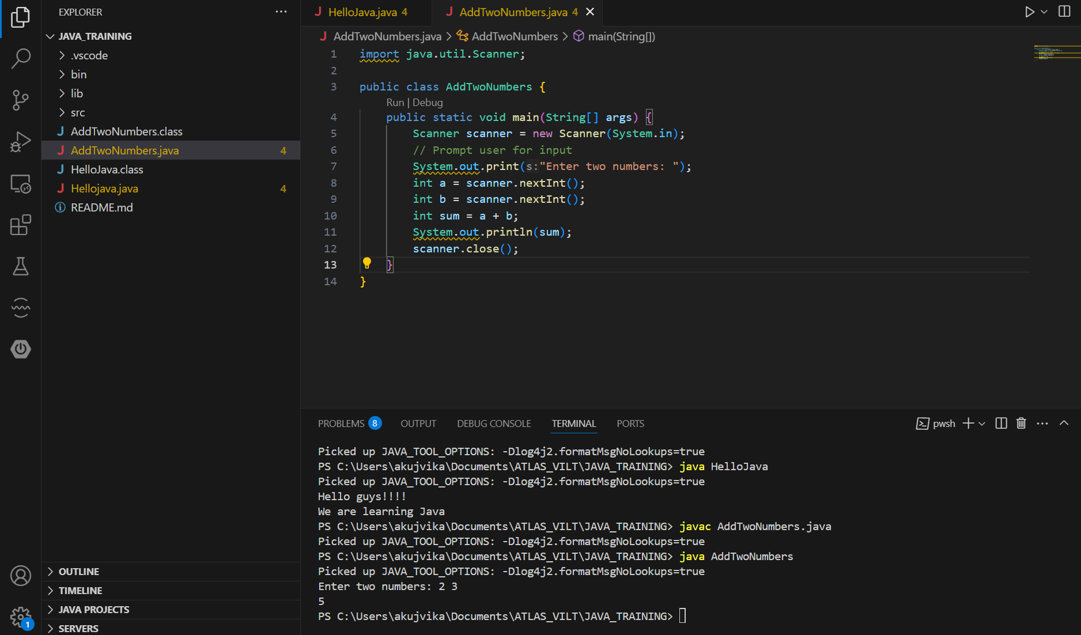

Task 003:

Write a Program to Swap Two Numbers

Input: a=2  b=5

Output: a=5  b=2

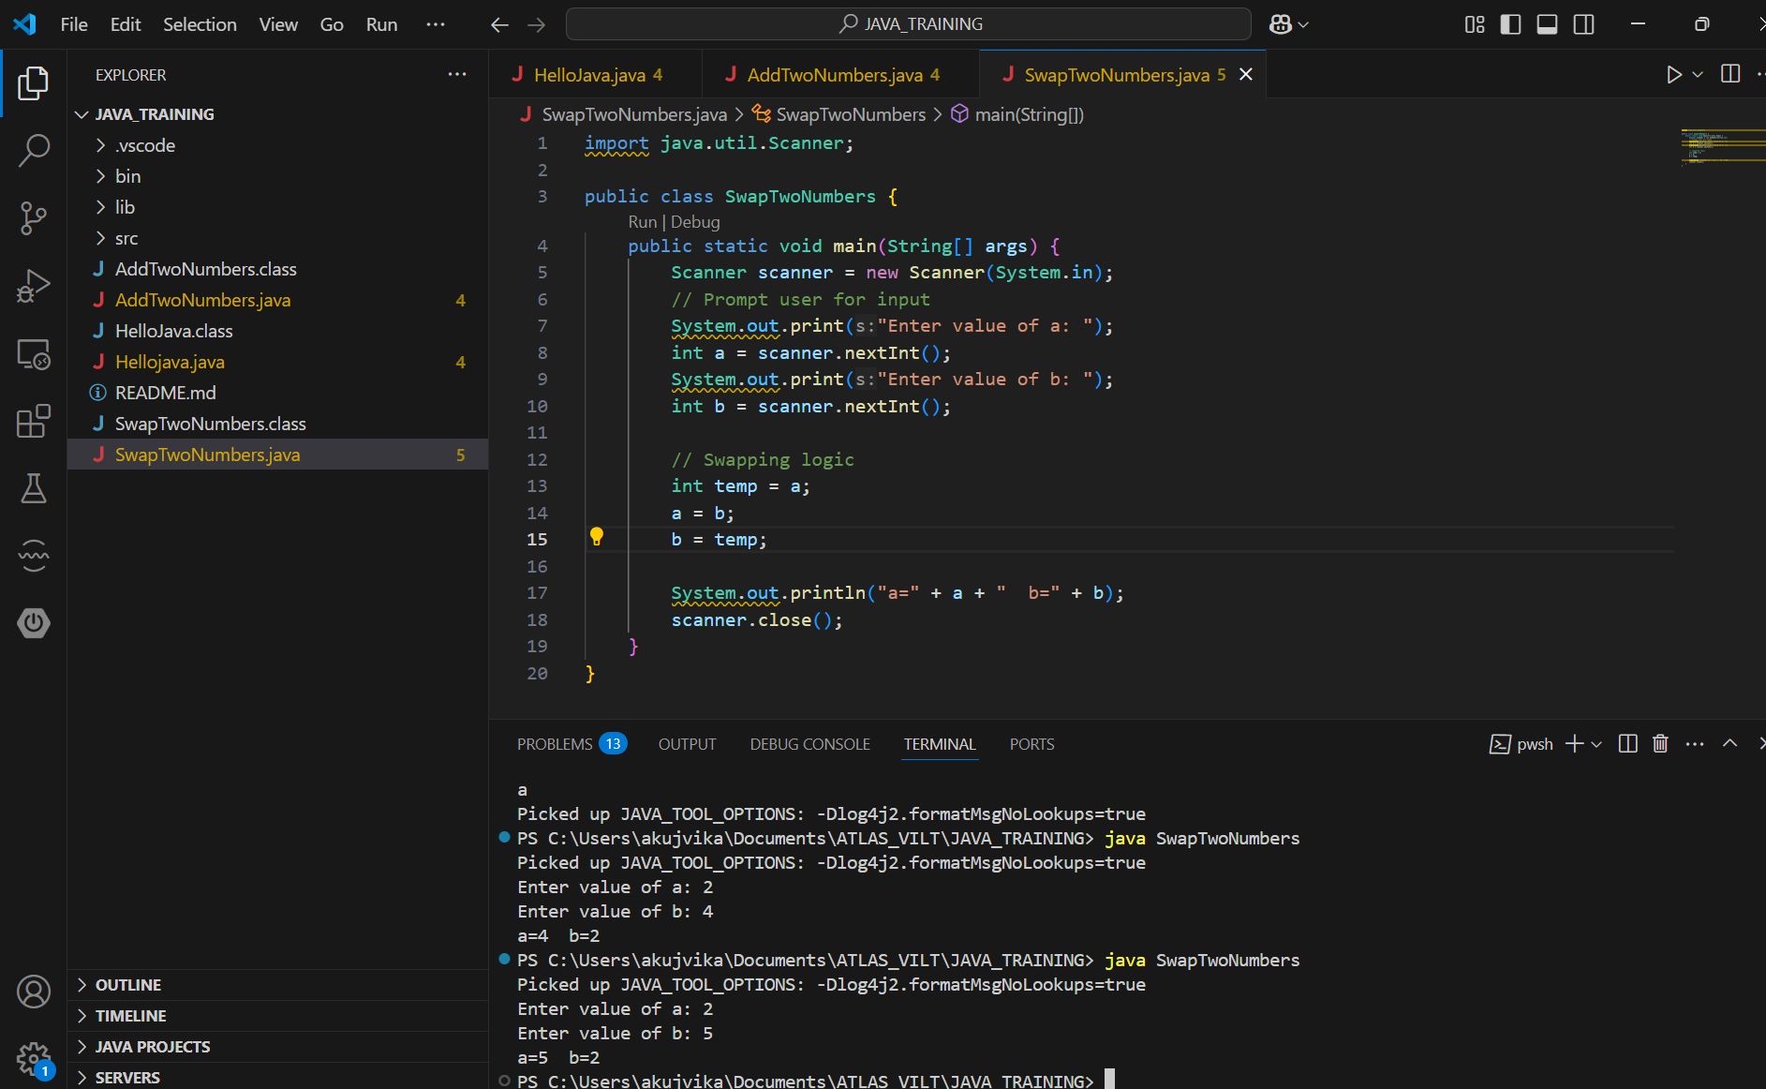

Task 004:

 Create a code in which you have 4 methods add, subtract, multiply and divide (return type int) with a main [method..to](http://method..to) all all the other methods

Out put:

Main started

Sum of 2 numbers is …..

Diff of 2 numbers is —-

Product of 2 numbers ….

Division of 2 numbers is ….

Main ended

12.01 to 12.08

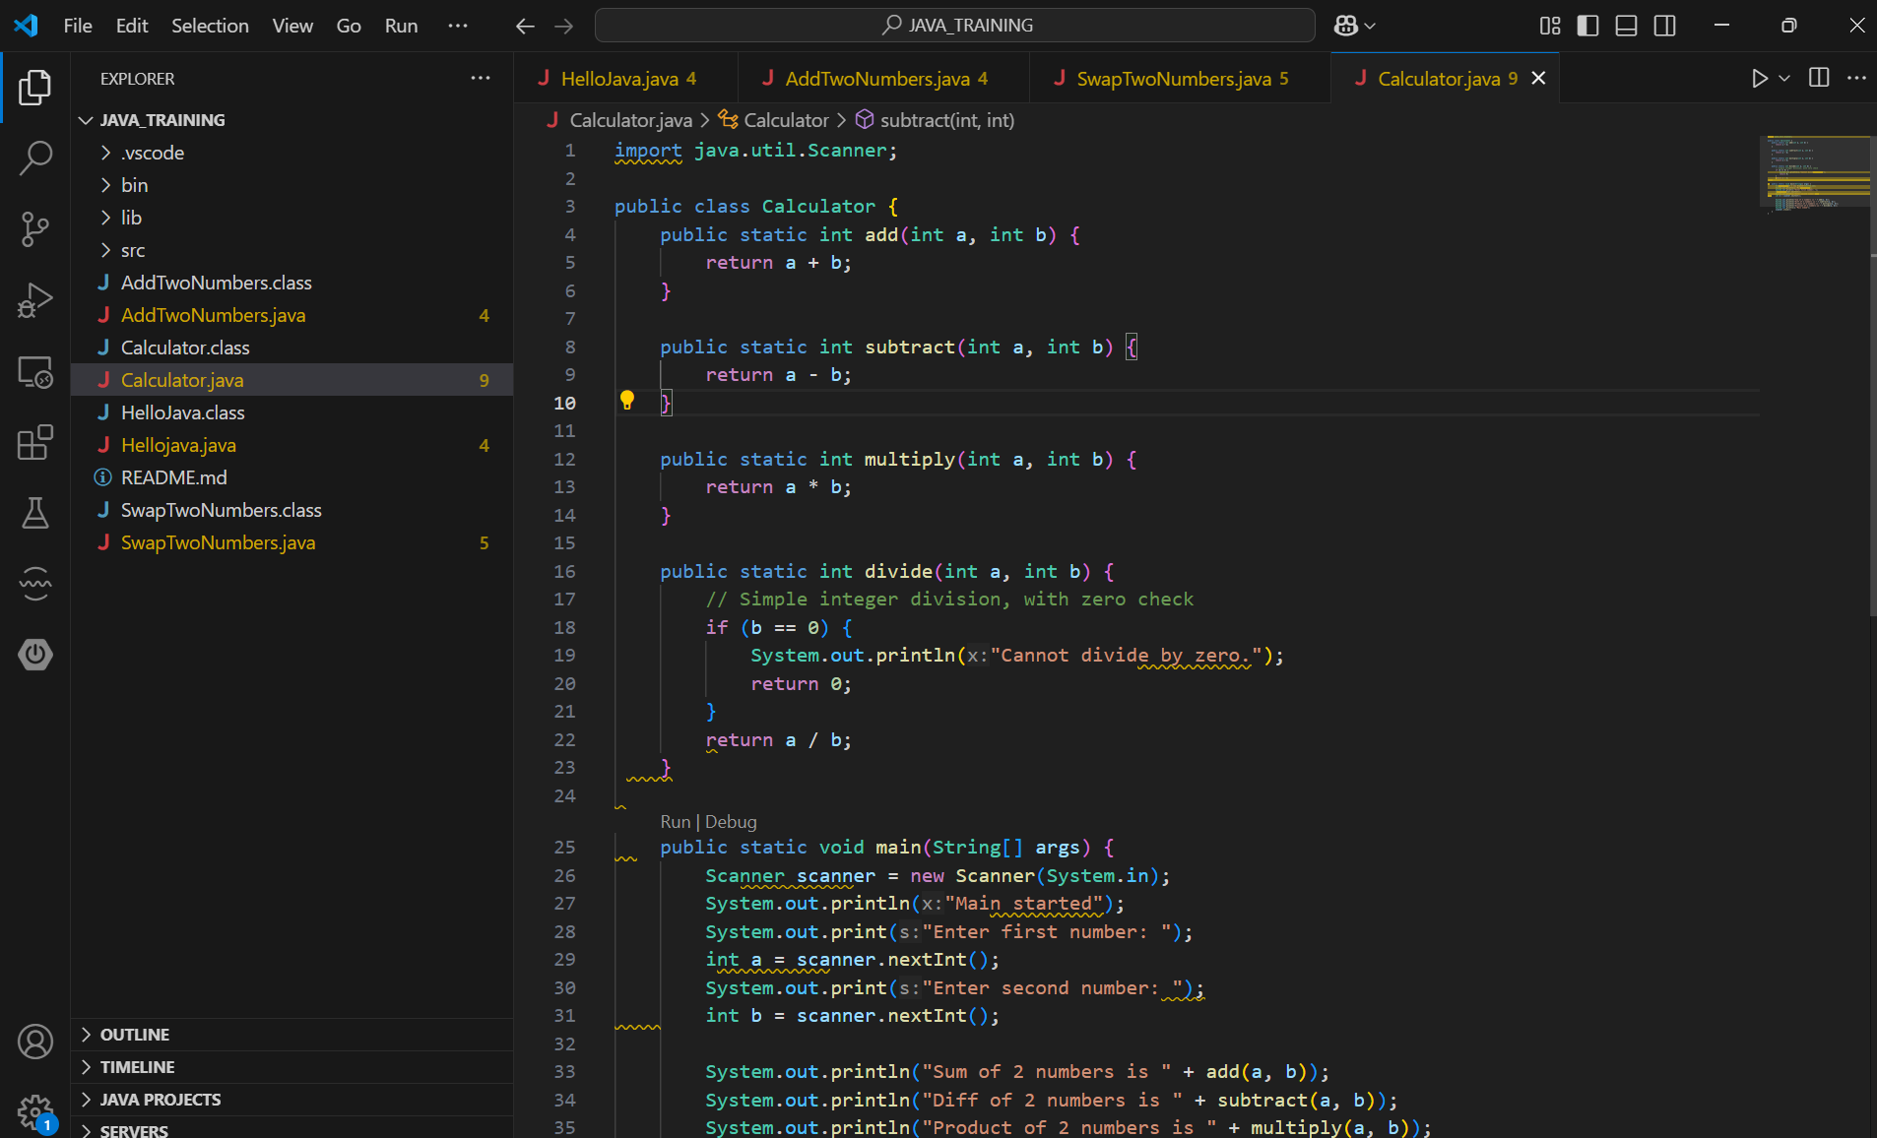

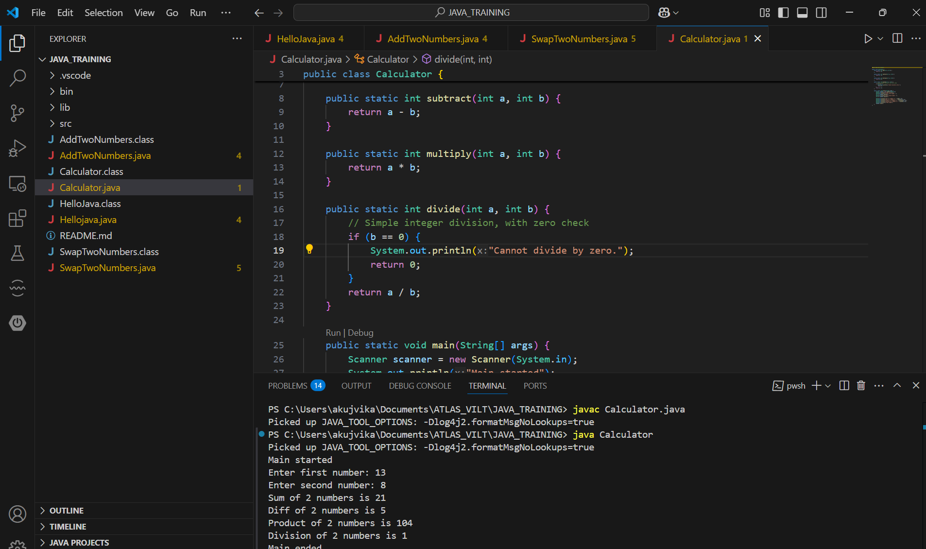

Task 005:

Write a program to check if a is greater or b.. Use ternary op

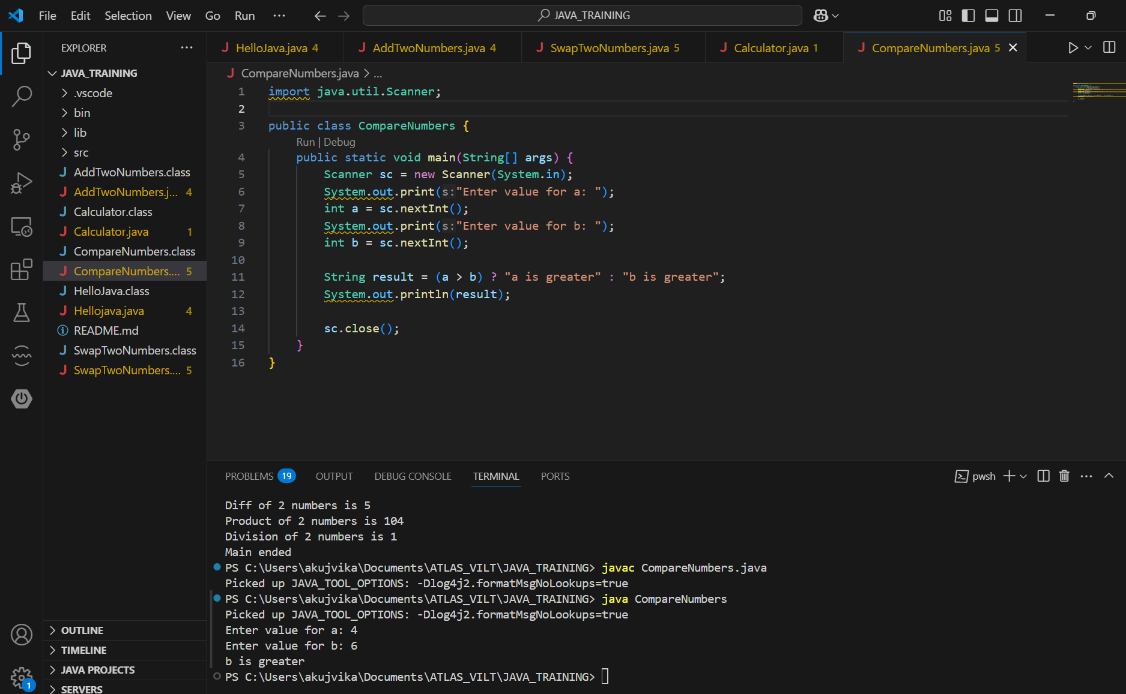

Task 006:

Write a program to take input from the user and display it to the user

Input:

Id : Prasunamba

Pwd: 123456789

Output:

Hi ,

Your login id is Prasunamba

And your pwd is *********

HInt :

For scanner … import java.util.scanner;

Scanner sc = new Scanner([System.in](http://system.in));

Id = sc.nexLine();

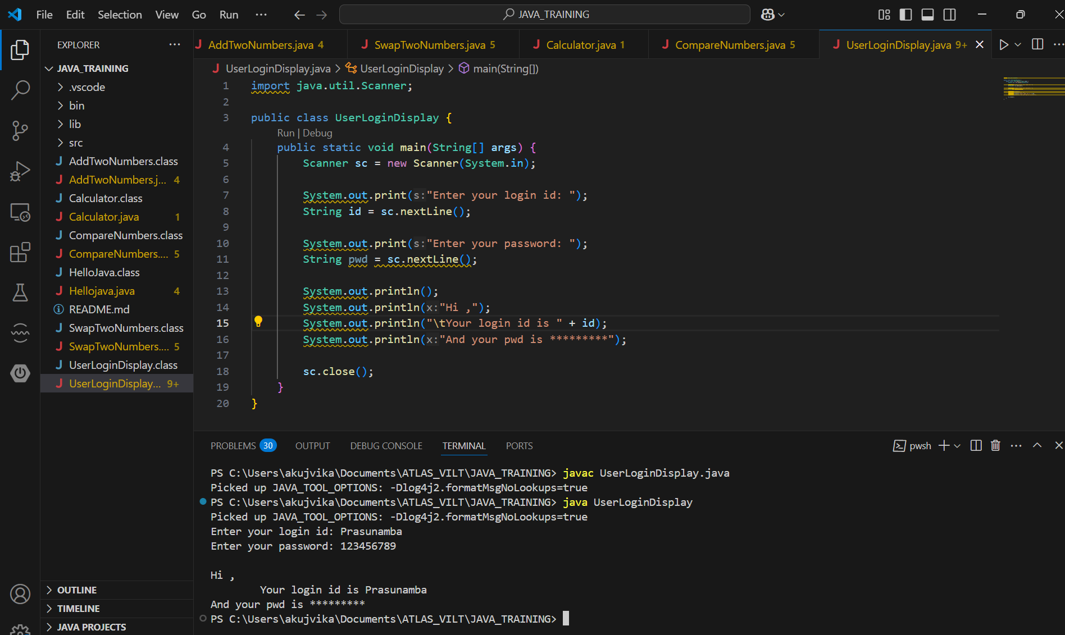

Task 007:

Write a program to create a class named Customer

Call the customer class in Task007 class using an object

Hint

In the main method

Class Customer{

  Void accept(){

sysout(“accept customer called”);

}

Void display(){

sysout(“display customer called”);

}

}

Public class Test007{

psvm(String[] argos){

Customer cobj = new Customer();

cobj.accept();

cobj.display();

}

}

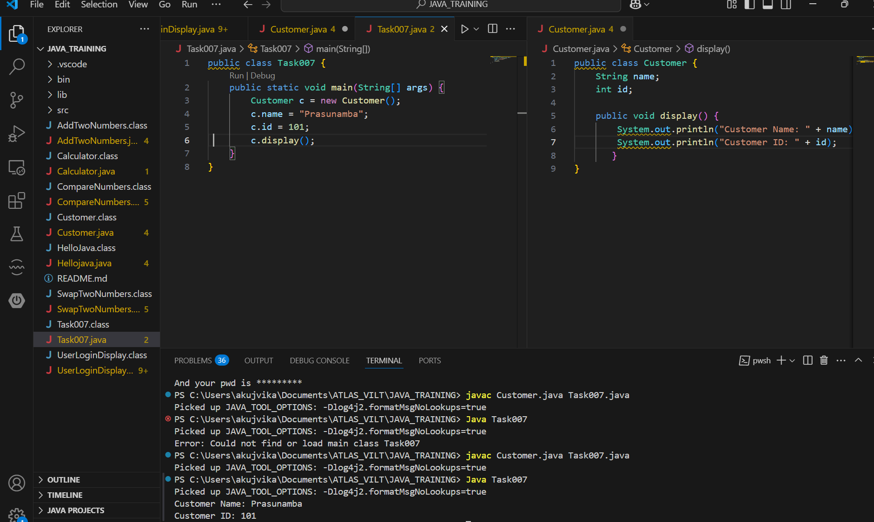

Task 008:

Wap to check the greater of 2 numbers

Hint:

Use if else

If ( num1 > num2){

sout(“num1 is greater”);

}

Else {

sout(“num2 is greater”);

}

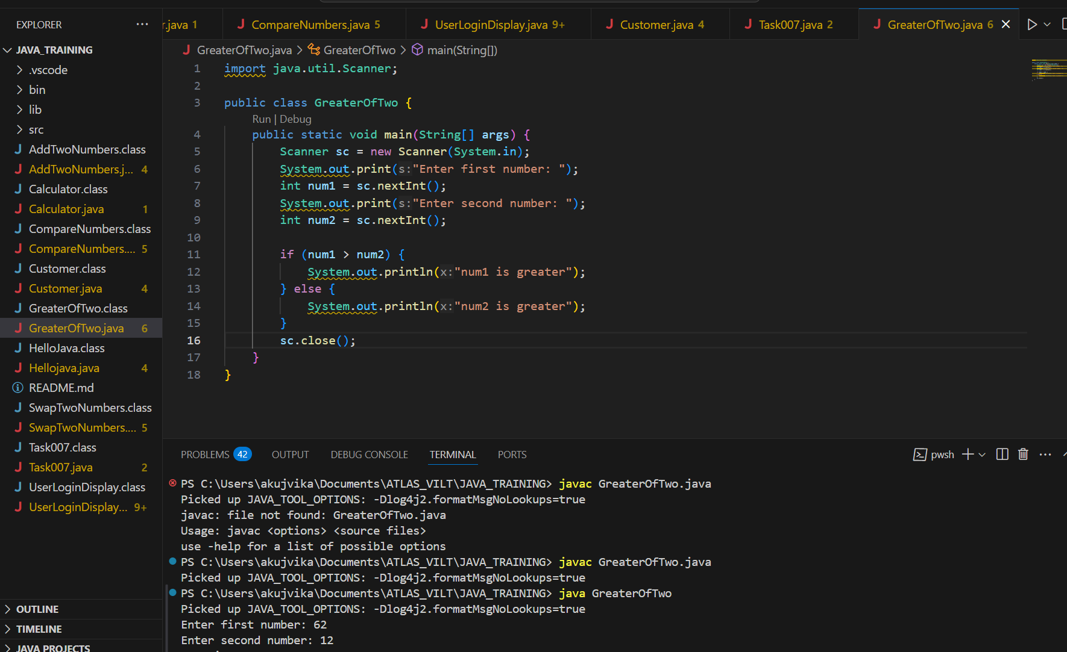

Task 009

Wap to check greater of 3 numbers

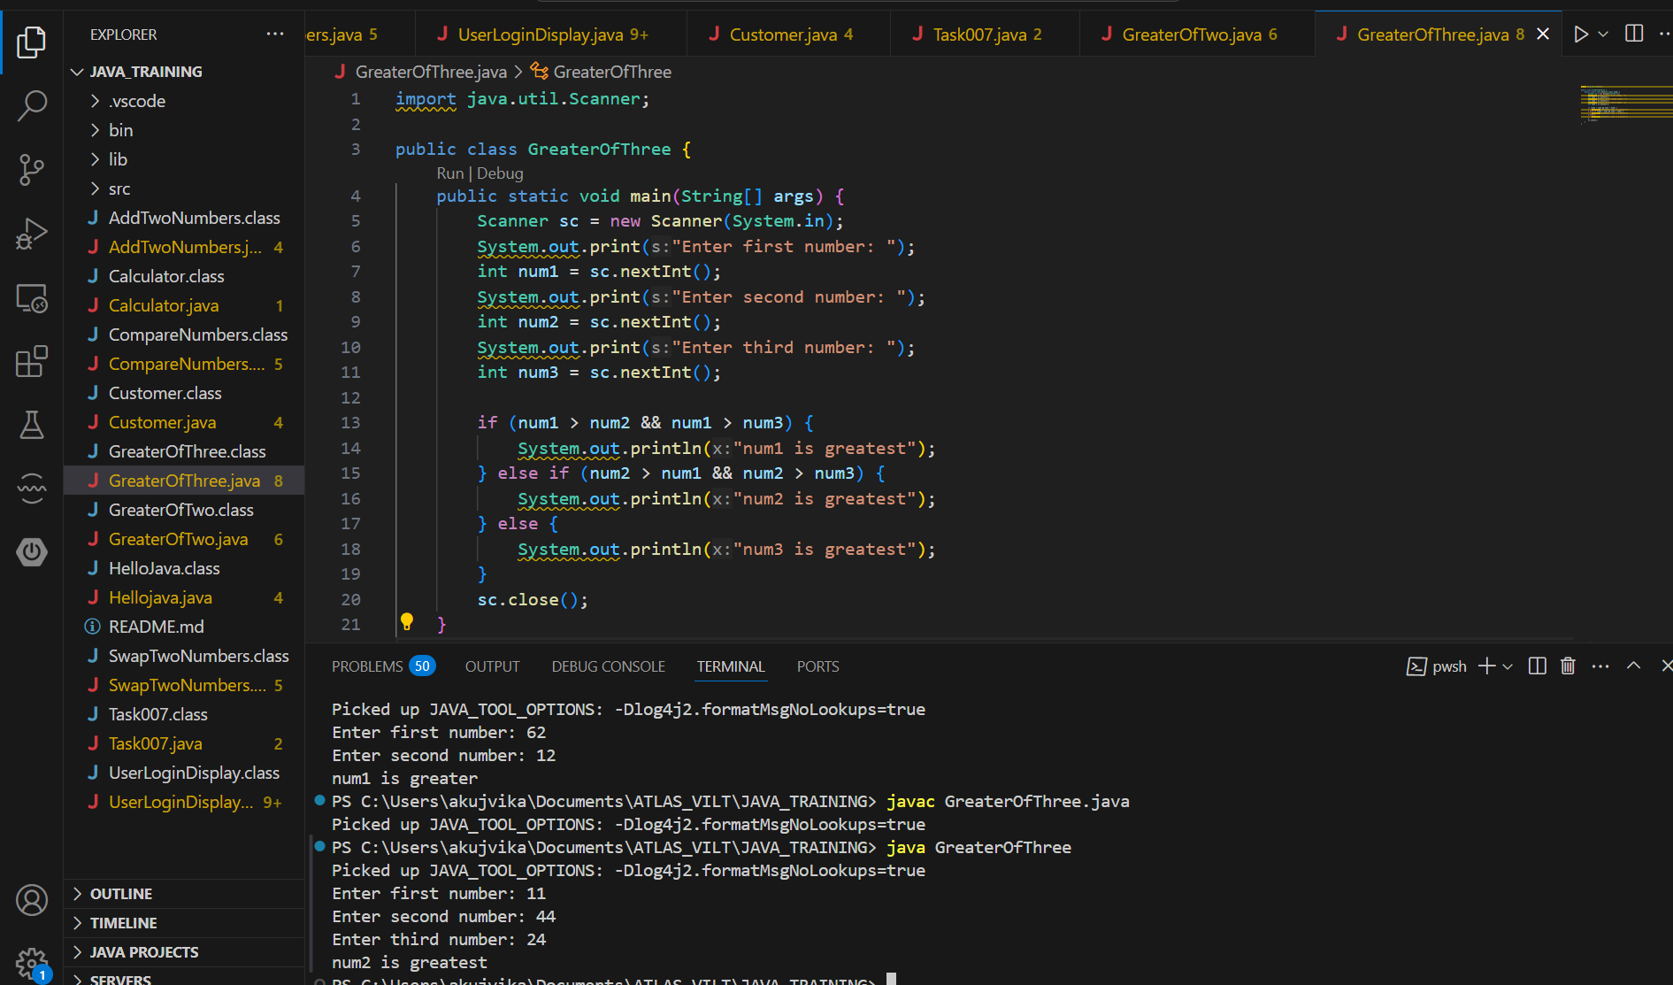

Task 010:

Wap to check if check week days

1  ===> sunday

2 ===> monday

So on

8 and above ===> invalid input

Hint : use Switch case

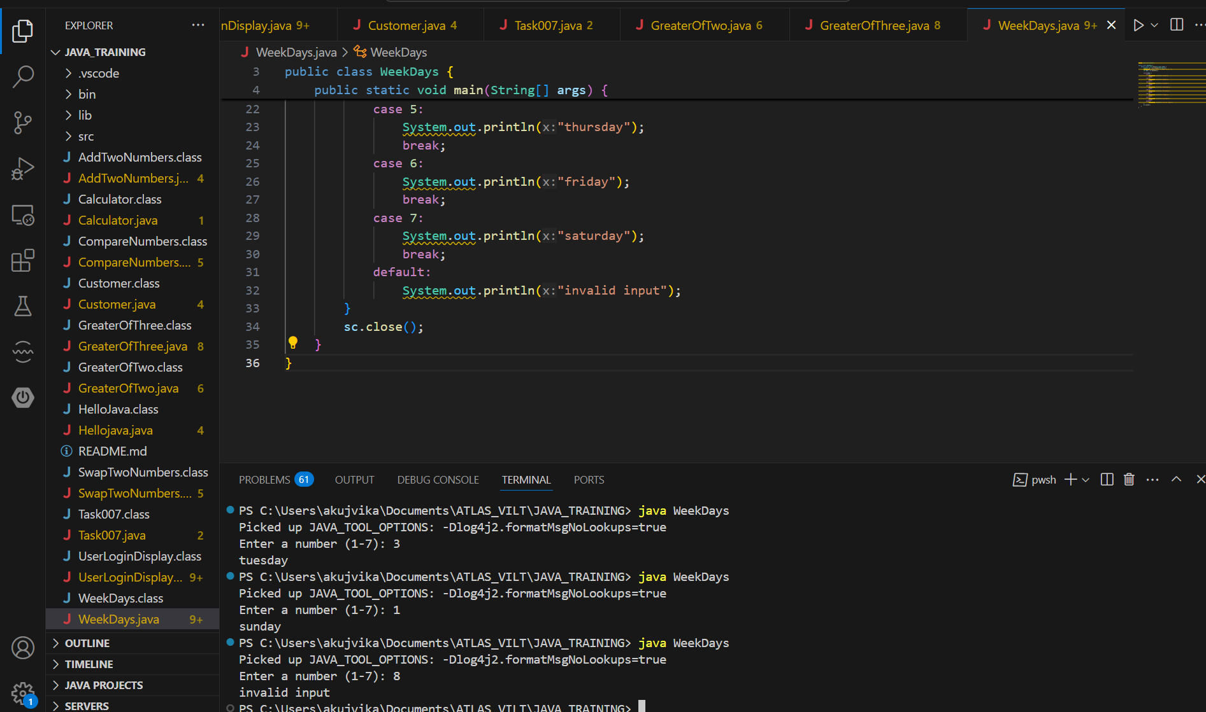

Task 011:

Wap to check loginid and password validation

Hint use while loop

Scanner sc = new Scanner(System.in);

String loginid = “Prasunamba”

String pwd = “12345867”

Int Count = 0;

While (loginid == “Prasunamba” && pwd == “12345867”){

sout(“ you have logged in for  ”+ count++ +” times”);

sout(“enter ur login id and password”);

loginid = sc.NextLine();

pwd = sc.NextLine();

}

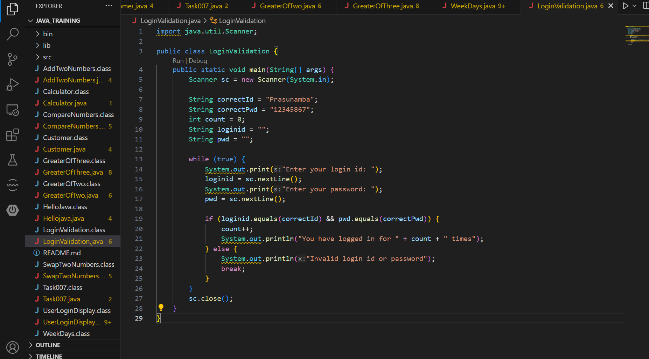

Task 012:

Same as above qn but use do while loop

Scanner sc = new Scanner(System.in);

String loginid = “Prasunamba”

String pwd = “12345867”

Int Count = 0;

do{

sout(“ you have logged in for  ”+ count++ +” times”);

sout(“enter ur login id and password”);

loginid = sc.NextLine();

pwd = sc.NextLine();

}While (loginid == “Prasunamba” && pwd == “12345867”);

sc.close();

While and do while loops - indefinite loops

For loop is definite…

For (initialization exp; condition exp; incre or decre exp)

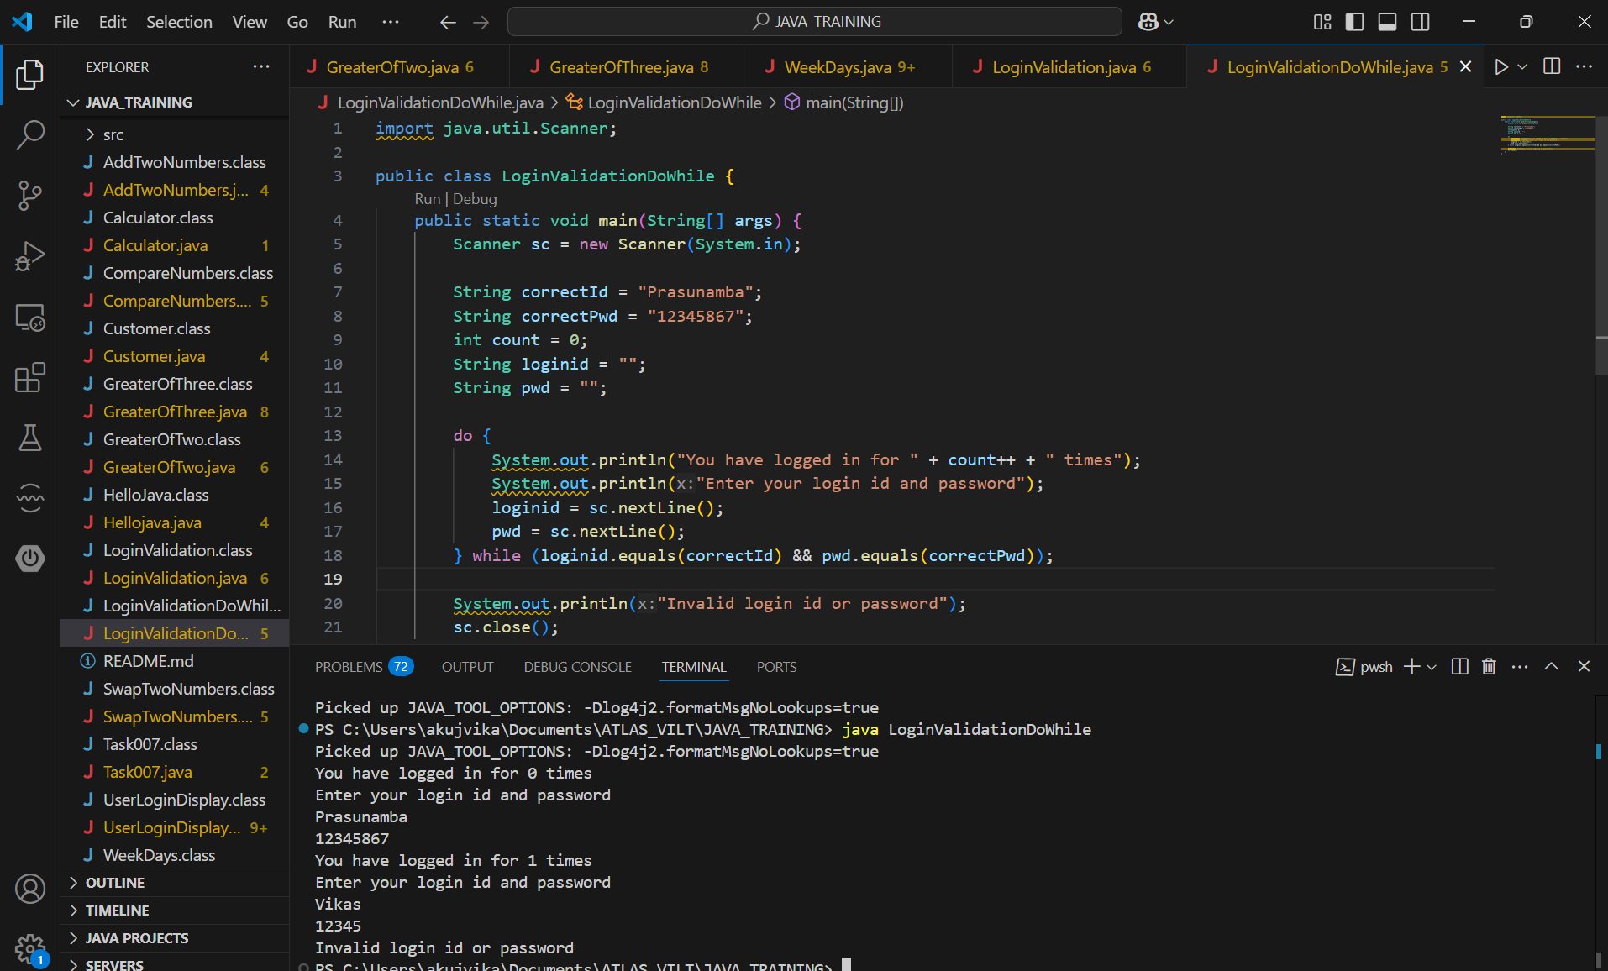

Task 013:

Wap to display numbers from 10 to 1 .. skip 7 and 5.

for(int i= 10; i >0; i–){

If ( i == 5 || i == 7){

Continue;

sout(i);

}

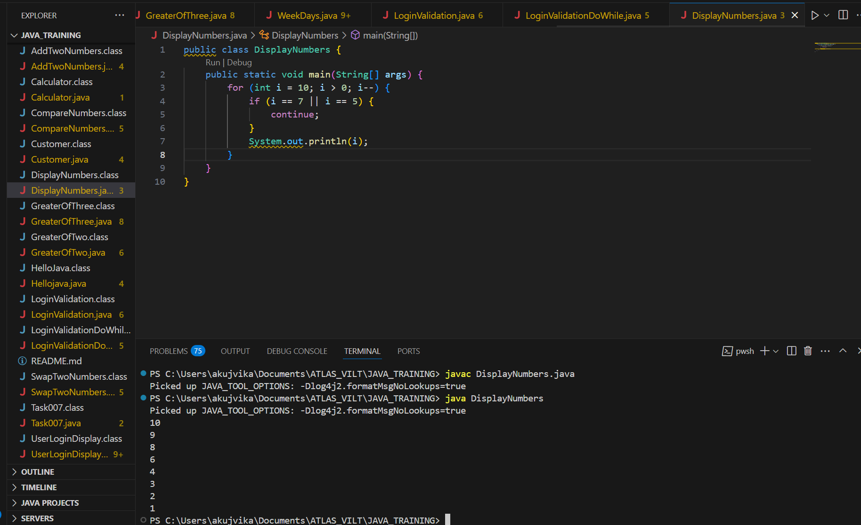

Task 014:

Arrays:

Try the below code and display the output…

Now play with it try to access arr of 5th index and see the output…and try to access arr of -1 index and see the output..

package Arrays;

public class Demo01 {

public static void main(String[] args) {

// TODO Auto-generated method stub

char[] arr = {'a','e','i','o','u'};

System.out.println(arr);

String[] names = {"Meena", "Tina", "Veena", "heena"};

System.out.println(names[0]);

names[1]= "Reena";

System.out.println(names[1]);

System.out.println(names.length);

System.out.println(names[4]);

//Exception in thread "main" java.lang.ArrayIndexOutOfBoundsException

}

}

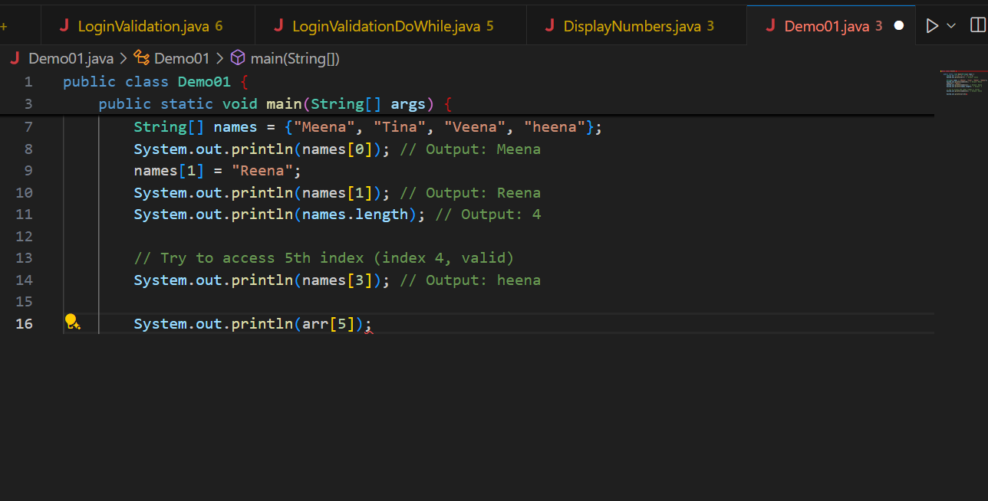

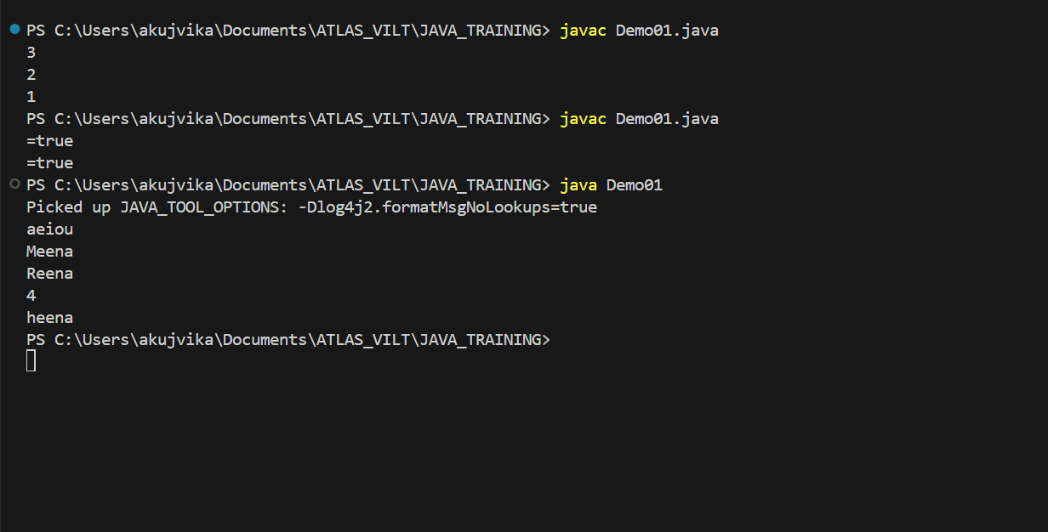

Strings:

Task 015:

package StringHandling;

public class Demo01 {

public static void main(String[] args) {

// TODO Auto-generated method stub

String str1 = "Java Strings "; // string Literal

String str2 = new String(str1); // obj of the string - new keyword

String str3 = new String("are easy to learn ");

char ch[] = {'S', 't', 'r' ,'i', 'n', 'g'};

String str4 = new String(ch);

System.out.println(str1 + "\n" + str2 + "\n" +str3 + "\n" +str4);

}

}

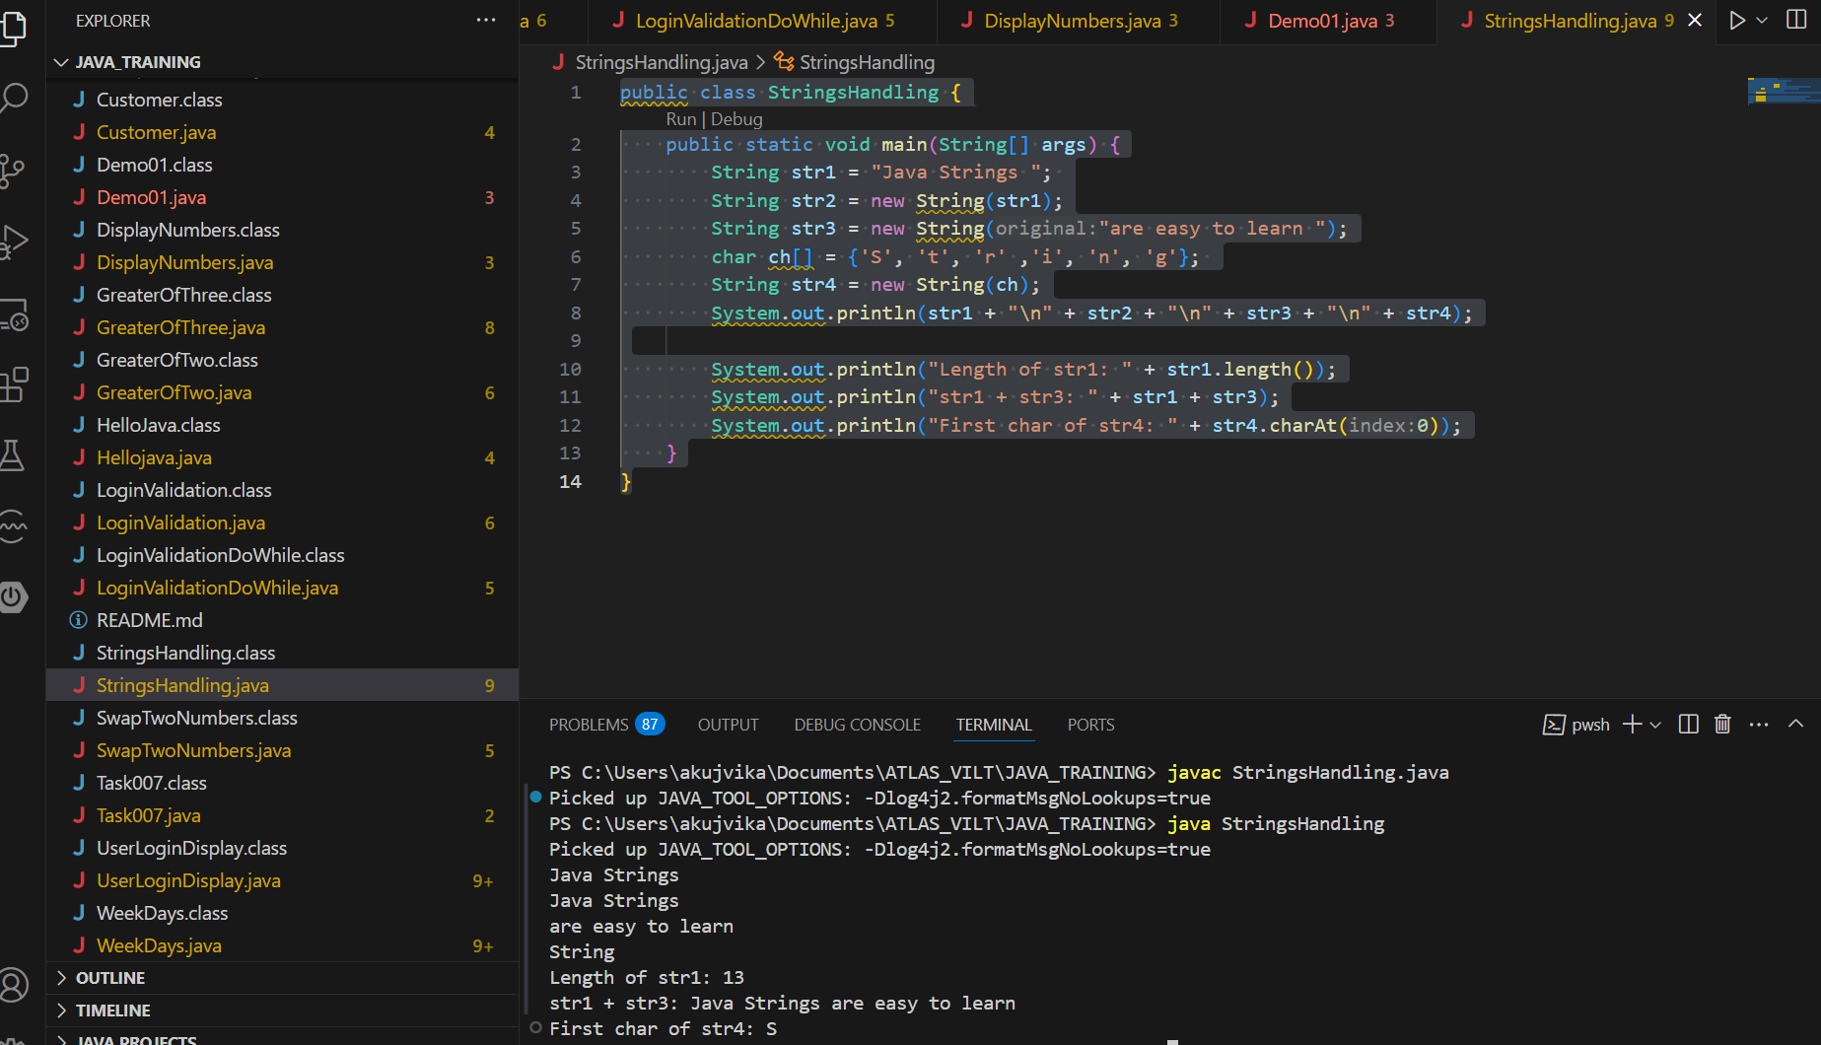

Task 016

Enums or Enumerations

What is the output of the below code snippet

package Enumerations;

enum color{

red, blue, green, yellow

}

public class Demo01 {

public static void main(String[] args) {

color c1 = color.yellow;

System.out.println(c1);

}

}

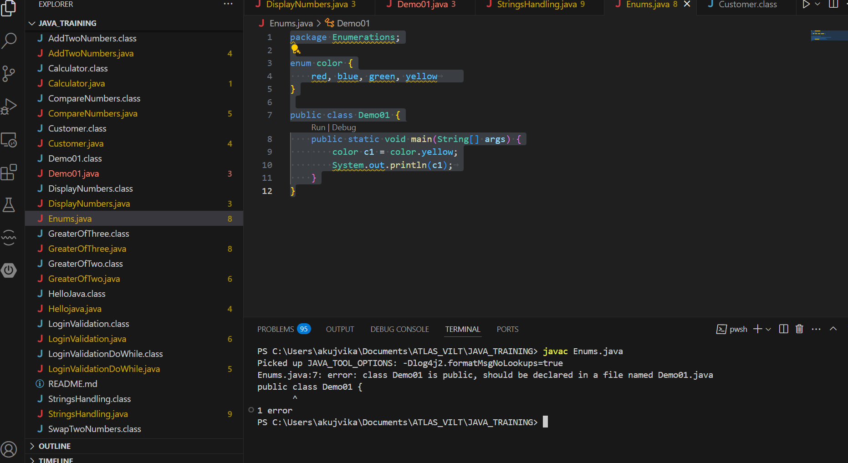

Task 017:

Getter and setter

Create a program name Person.java

public class Person {

   private String name;

   // Getter

   public String getName() {

     return name;

   }

   // Setter

   public void setName(String newName) {

     this.name = newName;

   }

}

Create another program named Task017.java

public class Task017{

  public static void main(String[] args) {

    Person myObj = new Person();

    myObj.name = "John";

    System.out.println(myObj.name);

  }

}

—----------------------------------what is the reason for the error —---------------explain

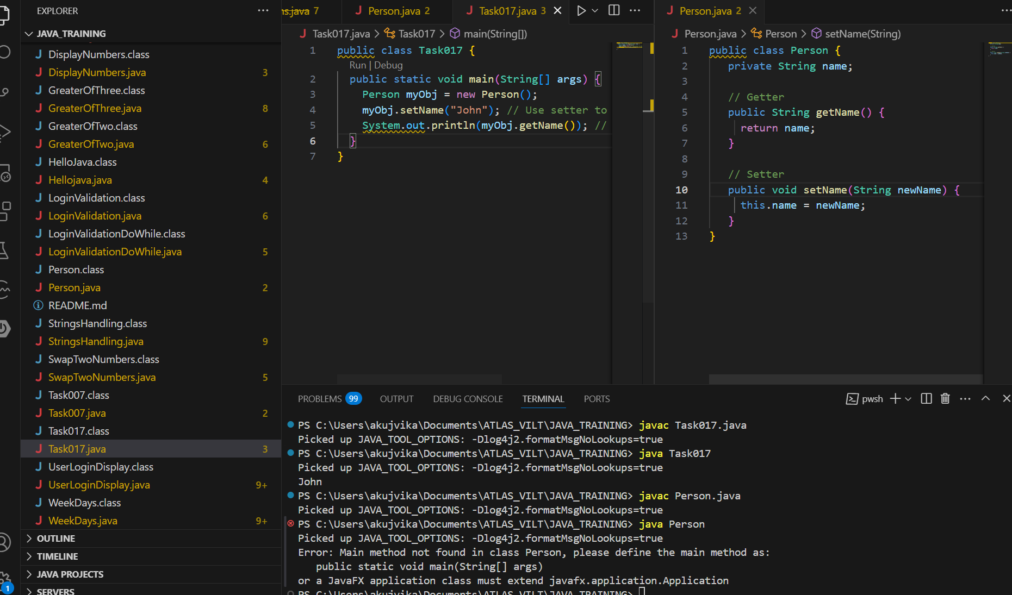

We will get a compilation error in Task017.java at the line

The name field in the Person class is declared as private.

private means it can only be accessed within the Person class itself.

You cannot access or modify name directly from outside the class (like in Task017).

To fix this, we should use the setter and getter methods

The error occurs because you are trying to access a private variable directly from outside its class, which is not allowed in Java. Use getters and setters to access private fields.

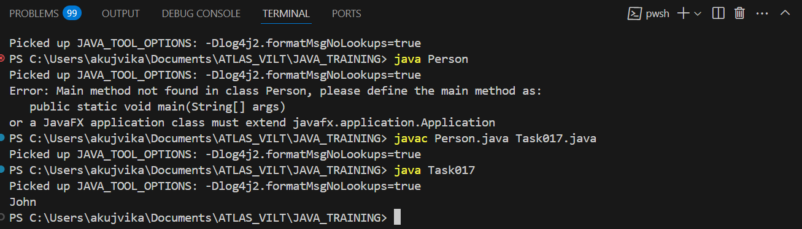

Task 018

Now create one more program named Task018.java

public class Main {

  public static void main(String[] args) {

    Person myObj = new Person();

    myObj.setName("John");

    System.out.println(myObj.getName());

  }

}

Now —--------------think what is the output of the above code—--------------

